Grade Sheet for Lab #1 Fan 2016.

Group Number-'-:-_3_0 _

Group Member Name: *<;'eDV* St alf *C< S* Student Number: *!J(,o* b3*°1 S-(* '2 Group Member Name:Gor.v ( *c i ,,,a h?* Student Number: ·2 *,.; oG -s 1or*

Marks

1. Schematic dia ram for the 6-bit com arator

|  |
| --- |
|  |
|  |
| ?_ |
| "Z |
| 2- |
| 2- |
| 7 |

1. VHDL file for the 6-bit com arator
2. Initial artial simulation results for the 6-bit com arator
3. Com lete simulation results for the 6-bit com arator
4. VHDL descri tion for the 16:4 encoder circuit
5. Simulation Testbench VHDL for the 16:4 encoder circuit
6. Simulation results for the 16:4 encoder circuit

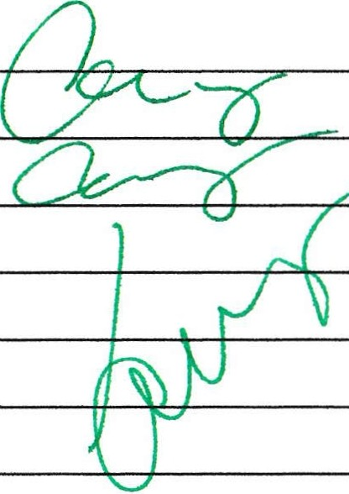

TA Signatures

Each part should be demonstrated to one of the TAs who will then give a grade and sign the grade sheet. Grades for each part will be either 0, 1, or 2. A mark of 2 will be given if everything is done correctly. A grade of 1 will be given if there are significant problems, but an attempt was made. A grade of 0 will be given for parts that were not done at all, or for which there is no TA signature.

l·.C'.-il' 323 1·2016 70